
PARENTS
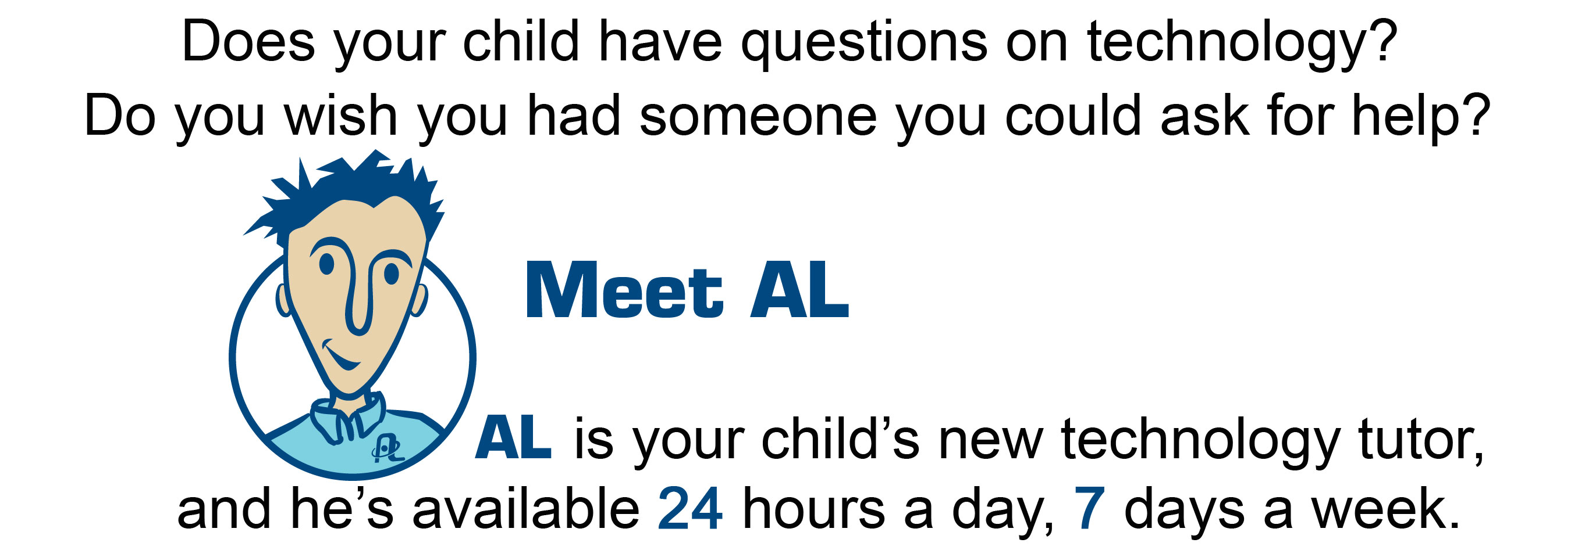

AL stands for Atomic Learning, our online resource for software training. AL is available to our students and their families in school and at home throughout the school year.

Atomic Learning’s “just-in-time” approach to software training focuses on answering the common questions encountered when learning and using software. How do you cut and paste in Word? Is your child making a PowerPoint presentation and looking for help? How do you type a formula in Microsoft Excel? Just ask AL.

- Go to www.atomiclearning.com
- Enter the following user name and password:
Students
    - User Name: bchs@bath.k12.va.us
    - Password: student
Parents (YES! You also get to use Atomic Learning! Jump In!)
    - User Name: parent@bath.k12.va.us
    - Password: parent
- Type your question in the search box and click on Search
- An answer will be provided in the form of a short, narrated movie. The movie will walk you and your child through all the steps needed to complete the task.


Bath County Public Schools is dedicated to providing the highest quality technology resources available. We’ve taken a big step forward in incorporating technology into our classrooms. That is why we are making Atomic Learning available to your family. We want you to have the resources to help your child with school work. Of course, you can also use AL to learn more about technology.

Have a question about technology?
Just ask AL.
www.atomicLearning.com


